**Mental Fitness Tracker**

D.H.B. Vignya

Department of CSM

Vignana Bharathi Institute of Technology

Hyderabad, India

vignyadurvasula@gmail.com

# **Abstract**

Mental health is often ignored and forgotten about. Mental fitness is as vital as physical fitness for the happy and healthy living of a human being.

If any illness is left unnoticed, it could hinder the growth of the person.

There are many mental health trackers in the market that are helpful to track the mental fitness.

# **Introduction**

Research shows that 90% of the severe and untreated mental illnesses are found in young adult techies.

This project is developed based on a Tech survey that is conducted in different IT sectors and the results are very surprising.

This survey shows that at least 25% of the employees have no proper medical care or care options.

When asked about the type of work they do, most of the employees answered remote work.

**Dataset**

The dataset is from a 2014 survey that measures attitudes towards mental health and frequency of mental health disorders in the tech workplace.

**Training**

This dataset has a lot of missing and non-uniform values.

Non-uniformity in the data set may lead to predictions which are less accurate.

Therefore, filling the missing values and removing any redundancies will help in building an accurate model.

The data set has been split in the following ratio:

70%-Training data set

30%-Testing

Number of epochs-500

**Results**

After 500 epochs, the accuracy of the model is 67.46%.

The accuracy v/s Time graph is obtained as:

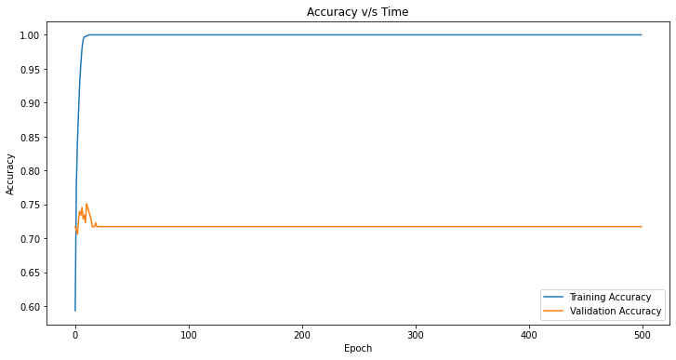

**Acknowledgments**

I would like to thank the team of Edunet for this opportunity, and the assigned mentors for their constant support.

**References**

Dataset- <https://www.kaggle.com/datasets/osmi/mental-health-in-tech-survey>

Article by CDC on mental health- <https://www.cdc.gov/mentalhealth/learn/index.htm>